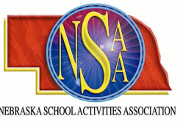

NSAA Basketball Officials’ Clinic

3-Person Mechanics Clinic

Sidney High School
October 27, 2007

Carlos Flores will be conducting a 3-Person Basketball Clinic on October 27, 2007. The purpose of the clinic is to review and improve the 3-person officiating mechanics for both new and veteran officials. The NSAA will continue to use 3-person crews for the 2008 post season basketball tournaments.

The clinic will begin at 9:00 AM MST at Sidney HS, 2103 King St, Sidney, NE

$25 Registration Fee

Contact Larry Mollring for additional information at the Nebraska School Activities Association.

Complete the registration form with all necessary information and enclose payment of $25.00
Return by October 20, 2007.
---------------------------------------------------------------------------------------------------------------------------

Name:_____________________________

Address:____________________________

City, State, Zip:_______________________

Telephone #: _________________________

E-mail:______________________________

Make check Payable to NSAA and mail to: NSAA, PO Box 5447, Lincoln, NE 68505-0447

